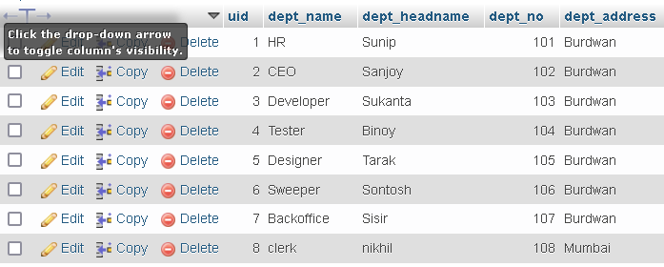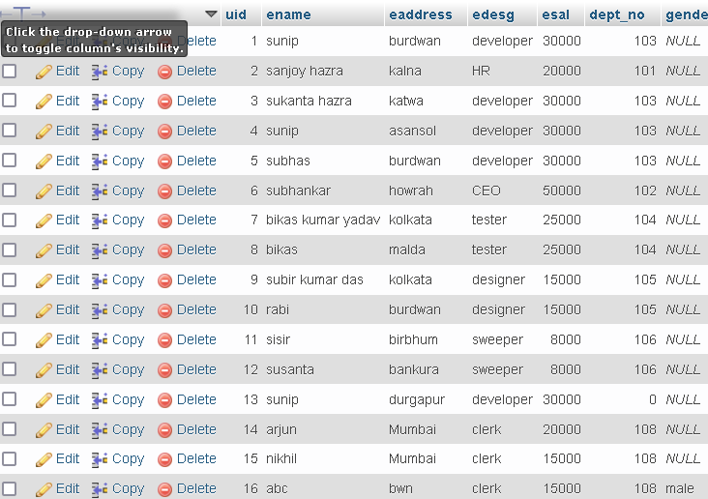T.N- emp T.N-dept

1. **Find the same employee name from your table.**

SELECT ename,COUNT(ename)

FROM `emp`

GROUP BY ename

HAVING COUNT(ename)>1;

**Output:**

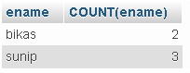

1. **Find the employee salary who is in “Mumbai” and Dept.name is “clerk”.**

SELECT emp.ename,emp.eaddress,dept.dept_name,emp.esal

FROM emp INNER JOIN dept

on emp.dept_no=dept.dept_no

AND dept.dept_name="clerk"

AND emp.eaddress="Mumbai";

**subquery**

**Output:**

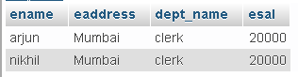

1. **Find the dept.no from dept. Table who live in “Mumbai”.**

SELECT emp.ename,emp.eaddress,dept.dept_no

FROM emp INNER JOIN dept

on emp.dept_no=dept.dept_no

AND emp.eaddress="Mumbai";

**Output:**

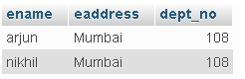

1. **Find the employee whose middle name is “kumar”.**

SELECT ename

FROM `emp`

WHERE ename LIKE "%kumar%";

**Output:**

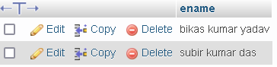

1. **Find the second highest salary of the employee whose Dept.name is  
   “Clerk”.**

SELECT emp.ename,emp.esal,dept.dept_name

FROM emp INNER JOIN dept

ON emp.dept_no=dept.dept_no

AND dept.dept_name="clerk"

AND emp.esal IN(SELECT MAX(esal)

FROM emp

WHERE esal<(SELECT MAX(emp.esal)

FROM `emp` INNER JOIN dept

ON emp.dept_no=dept.dept_no

AND dept.dept_name="clerk"));

**Output:**

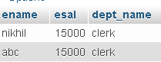

1. **Find, how many employees work in “Mumbai”?**

SELECT COUNT(eaddress)

FROM `emp`

WHERE eaddress="Mumbai";

**Output:**



1. **Find all combinations of one employee who gets the  chances  
   to match deptno from the dept table.**

SELECT emp.ename,emp.eaddress,emp.edesg,emp.esal,emp.dept_no

FROM emp INNER JOIN dept

ON emp.dept_no=dept.dept_no;

**Output:**

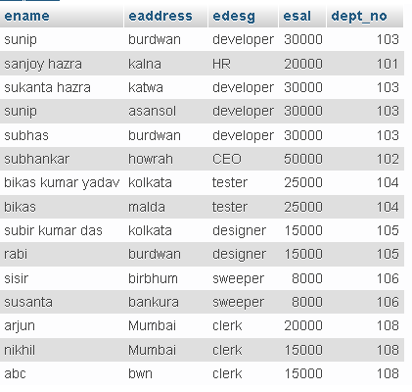

1. **Find the employee salary who earns the greater than the avg salary  
   of a total salary.**

SELECT ename,esal

FROM emp

WHERE esal>(SELECT AVG(esal) FROM `emp`);

**Output:**

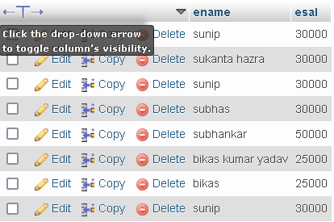

1. **Create a primary key of a table, insert the data into this  
   attribute. Find how to insert the data in another table from the first table?**

CREATE TABLE parent1( roll int(200), name varchar(200), address varchar(200), PRIMARY KEY(roll));

**Output:**

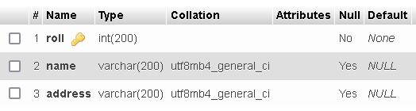

INSERT INTO `parent1`(`roll`, `name`, `address`) VALUES (1,'sunip','burdwan');

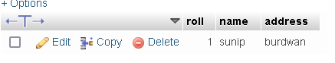

Insert the data in another table from the first table

INSERT INTO student

SELECT * FROM parent1

1. **Find the employee name ,whose surnames are equal.**

SELECT ename

FROM `emp`

WHERE ename LIKE "%hazra";

**Output:**

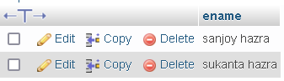

1. **Take three tables, second table has primary key of first and third table has a primary key of second how will you insert and delete data between three tables.**

T.N.- table1

[CREATE](http://localhost/phpmyadmin/url.php?url=https://dev.mysql.com/doc/refman/8.0/en/create-table.html) [TABLE](http://localhost/phpmyadmin/url.php?url=https://dev.mysql.com/doc/refman/8.0/en/create-table.html) table1( roll [int](http://localhost/phpmyadmin/url.php?url=https://dev.mysql.com/doc/refman/8.0/en/numeric-types.html)(200), name [varchar](http://localhost/phpmyadmin/url.php?url=https://dev.mysql.com/doc/refman/8.0/en/string-types.html)(200), address [varchar](http://localhost/phpmyadmin/url.php?url=https://dev.mysql.com/doc/refman/8.0/en/string-types.html)(200), PRIMARY KEY(roll));

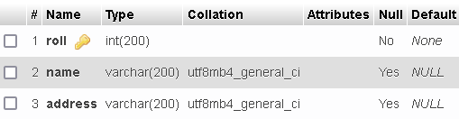

T.N.-table2

CREATE TABLE table2( roll int(200),dept_no int(200), degree varchar(200),PRIMARY KEY(dept_no), FOREIGN KEY(roll) REFERENCES table1(roll));

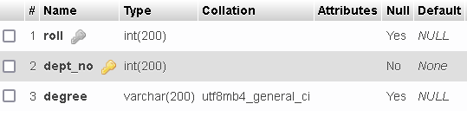

T.N.-table3

CREATE TABLE table3( dept_no int(200), deptname varchar(200), FOREIGN KEY(dept_no) REFERENCES table2(dept_no));

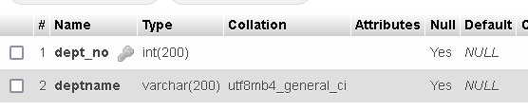

For insertion first insert data in table1 then insert data in table2 then insert data in table.

For deletion first delete data from table3 then delete data from table2 then delete data from table1.